Belkin High Speed Cable Modem
with USB and Ethernet
User Manual

P74206 F5D5530-W

Introduction
Congratulations on your purchase of this quality Belkin product. The Belkin High-Speed Cable Modem allows you to enjoy the Internet at full speed. If you are currently leasing a modem from you ISP, your purchase will save you money over time and eventually pay for itself. This Modem complies with DOCSIS 1.1 standards to ensure that it will work with your cable system for years to come. The Modem is also firmware upgradeable to ensure future compatibility.

Features

Ethernet or USB Installation
Flexibility to install any way you want to. USB Plug-and-Play technology makes connecting the Modem to your computer a snap.

Cable Labs Approved
Tested to the strictest standards to ensure unparalleled compatibility with your cable ISP.

DOCSIS 1.1 Compliant
Compliant to the latest in Cable modem technology.

Up to 43Mbps data rate
Supports Ultra fast data rates for surfing the net at high speed.

Vertical or Horizontal Desktop Application
Your Modem can stand vertically on the desktop to save space, or lay down flat on a shelf or under your Router. The included vertical mounting base lets you decide how to position the Modem.

Firmware Upgradeable
When necessary, the modem can be upgraded to work with improvements that your ISP may make to their system.

Hardware Specifications

Downstream (Receiver):
Demodulation: 64QAM, 256QAM
Data Rate: 30Mbps (64QAM), 43Mbps (256QAM)
Frequency Range: 88MHz to 860MHz
Bandwidth: 6MHz
Input Signal Level: -15dBmV to +15dBmV

Upstream (Transmitter):
Modulation: QPSK, 16QAM
Data Rate: 320K, 640K, 1280K, 2560K, 5120Kbps (QPSK)
640K, 1280K, 2560K, 5120K, 10240Kbps (16QAM)
Frequency Range: 5MHz to 42MHz
Bandwidth: 200KHz, 400KHz, 800KHz, 1600KHz, 3200KHz
Output Signal Level: +8 to +58dBmV (QPSK), +8 to +55dBmV (16QAM)

Other
USB USB 1.1 specifications
Ethernet Ethernet 10-baseT/100 Mbps
Cable Interface F-type female 75 ohm connector
LED Power / Cable / LAN / USB / Activity

Software Specifications
MIB Group SNMPv2 with MIB II, DOCSIS MIB and Bridge MIB
Baseline Privacy 40-bit/56-bit DES with RSA key management
USB OS Support Windows 98, Me, 2000 or XP

Package Contents
- Belkin High Speed Cable Modem
- Vertical Mounting Base (optional use)
- Category 5 Networking cable
- USB Cable
- Power Supply
- Software CD
- User Manual

System Requirements
- PC running Windows 98, Me, 2000 or XP
- CD-ROM drive (for USB software installation only)
- One available USB port (USB installation only)
- One RJ-45 Ehternet (networking) port (Ethernet Installation only)
- Active Cable Internet service from your Internet Service Provider (ISP)

Knowing Your Cable Modem
The Modem has been designed to be placed on a desktop vertically or horizontally, or it may be mounted to a wall. The slim design minimizes the desktop space required when placed vertically. All of the cables exit from the rear of the Modem for better organization and utility. The LED indicators are easily visible on the front of the Modem to provide you with information about network activity and status.
(1)

(2)

(3)

(4)

(5)

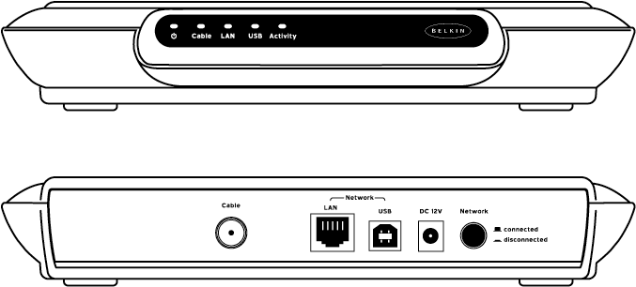
(6)

(7)

(8)

(9)

(10)

[F5D5530-W front-rear.tif]

(1) Power LED
When this LED is ON, the Modem is ON.

(2) Cable LED
This LED indicates the status of the Modem. When flashing fast, the Modem is scanning for a signal to lock onto. When flashing slowly, the Modem has locked onto a signal and is now negotiating the connection to your ISP. When the LED is ON solid, the Modem is connected to your ISP.

(3) LAN LED
When this LED is ON, there is a good connection between your computer or Router and the Modem.

(4) USB LED
When this LED is ON, there is a good connection via USB to your computer.

(5) Activity LED
When this LED is blinking, data is moving from or to the Internet through the Modem.

(6) Cable Connector
Connect the coaxial cable from the wall to this connector. Be sure to screw the connector on tightly.

(7) LAN Port
Connect a computer with an Ethernet port (networking port) to this port. You may also connect a Gateway Router to this port.

(8) USB Port
Connect a USB equipped computer to the Modem using this port.

(9) Power Jack
Connect the 12V DC power adapter to the Modem.

(10) Standby Switch
This switch allows you to disconnect your entire network (or single computer) from the Internet. Disconnecting your network from the Internet will disable Internet access to your computers and also keep outside traffic from the Internet from coming in on your Modem. If you leave your computer on all of the time, you might choose to disconnect it from the Internet when you are gone. This heightens the level of security if you are not running firewall software. If you want to restrict access to the Internet for children, you can use this switch when you cannot supervise your children. Press the switch IN to disconnect the network. Press it again and it will pop out. When the switch is out, your network is connected to the Internet.

LED Functions
Power | OFF | Router is OFF
 | ON | Router is On
Cable | OFF | Disconnected
 | Fast Blink | Scanning for signal
 | Slow Blink | Found Signal and negotiating
 | ON | Connected
LAN | ON | Connected to Ethernet
 | OFF | Ethernet Disconnected
USB | ON | Connected to USB
 | OFF | USB Disconnected
Activity | Blink | Transferring Data

Getting Started

You may be setting up your Internet service with your Cable ISP for the first time or you may be replacing an existing cable Modem. In either case, before installing the Modem, contact your ISP to inform them that you have purchased a new cable Modem. ISP’s vary in the process by which they activate the new modem. In some cases, the ISP will require that they send a technician to your home or office to set up the modem and activate it. In other cases, the Modem can be activated by your ISP over the phone or over the Internet. If so, your ISP will provide you with instructions for registering the Modem. The following directions are for users who can activate their Modem over the phone or over the Internet.

Setting up the Cable Modem
Make sure you have the following items with you:
- Belkin High Speed Cable Modem
- Vertical Mounting Base (optional use)
- Category 5 Networking cable
- USB Cable
- Power Supply
- USB Software CD
- User Manual

ISP’s that can activate the service for your modem over the phone or over the Internet will ask you for some product information. They may need all or some of the following:

- Modem MAC Address: Located on the bottom of the modem case.
- Modem Serial Number: Located on the bottom of the modem case.
- Modem Brand and Model number: Belkin, F5D5530-W

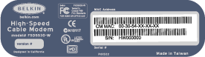
[MAC address location.tif]
MAC Address

Serial Number

Choosing your method of connecting the Modem to your computer
You can connect your Modem to your computer using two different methods. The Modem has a USB connection and an Ethernet connection. If you computer has an Ethernet (networking) port on it, use the Ethernet Port connection. If your computer does not have an Ethernet port on it, then use the USB connection.

Connecting the Modem to your computer using the Ethernet Port
If your computer is equipped with an Ethernet port (a networking port) you can connect your modem directly to the computer via this port. Follow the directions below.

- Turn off your computer.
- Connect the modem’s power supply cord to the power supply socket on the rear of the modem and the opposite end to an electrical outlet or power strip.
- Connect the coaxial cable from the wall to the round jack on the rear of the modem labeled “Cable”.
- Connect one end of the included Ethernet cable to the port labeled “LAN” on the rear of the cable modem and connect the other end to the Ethernet port on your computer.
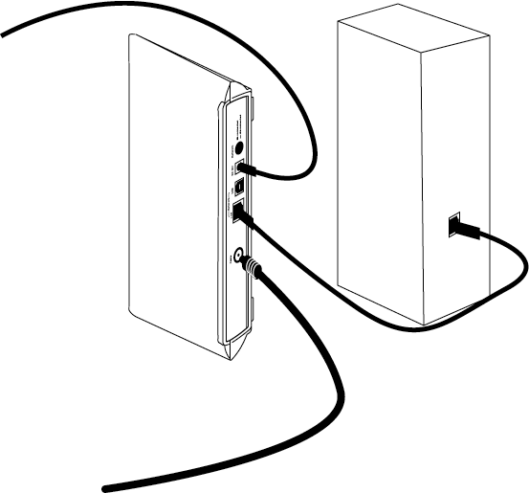
[F5D5530-W_Ethernet_to_PC.tif]
To Power Supply

Coaxial Cable (from wall)

Ethernet Cable

Ethernet Port on Computer

- Turn on your computer and let it boot up.
- Verify that the modem cables are connected properly by checking the LED indicators on the front of the modem. The Power LED and the LAN LED should be on solid. If they are not, see the troubleshooting section of the user manual.
- At this point, contact your ISP to register the Modem or follow the procedure that your ISP gave you to register your Modem over the phone or Internet.
- After your modem has been registered with your ISP, the installation is complete. Your Modem is ready to use.

- See the section called “Testing your Internet Connection”

Connecting the Modem to your computer using the USB Port
If your computer does not have an Ethernet port (a networking port) then you can connect the modem to your computer through an available USB port. Follow the directions below.

Install the Software first before connecting the Modem to the USB port on your computer.

- Insert the CD into your CD-ROM drive. The Belkin High Speed Cable Modem installer screen will appear. If it does not, select your CD-ROM drive. Double-click on the file called “setup.exe” to run the installer
- The installer will install the USB driver software onto your computer. Follow the on-screen steps.
Note: Windows 98 users may need their Windows 98 CD-ROM to complete Installation. If you do not have the CD and the installation wizard asks for it, you will need to locate it. Belkin cannot provide the necessary files to complete installation.
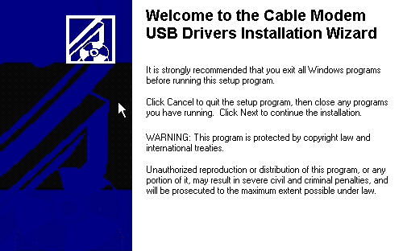[pic 1.tif]
- The following screen will appear. Enter your information and click “Next”
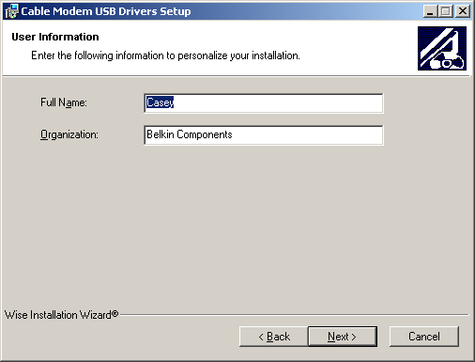[pic 2.tif]
- The following screen will appear. You can choose a destination folder for the files. Click “Next” to keep the current folder. Click “Browse” to change the folder.
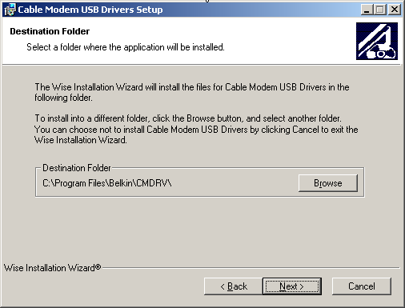[pic 3.tif]
- The following screen will appear. Click “Next”
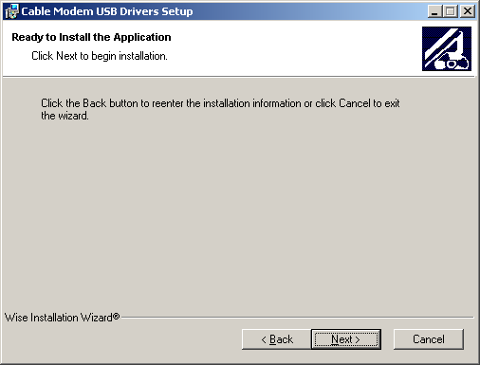[pic 4.tif]
- Click “Finish” to complete the software installation.
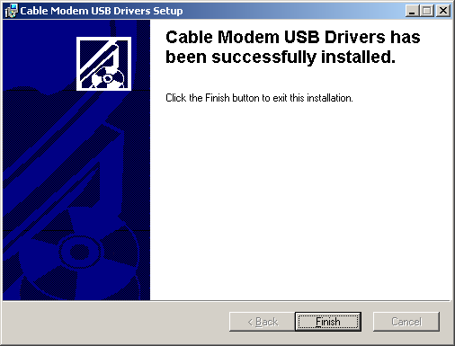[pic 5.tif]
- Connect the modem’s power supply cord to the power supply socket on the rear of the modem and the opposite end to an electrical outlet or power strip.
- Connect the coaxial cable from the wall to the round jack on the rear of the modem labeled “Cable”.

- Plug the included USB cable into the “Type B” socket of the cable modem. Connect the other end of the USB cable into an available “Type A” USB port on your computer. Windows will detect a new USB device and begin installation of the cable modem. After installation is complete check the front panel to confirm the USB LED is on.

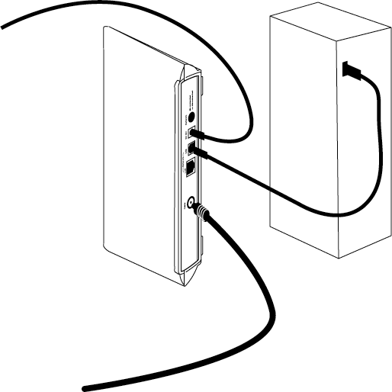
[F5D5530-W_USB_to_PC.tif]
To Power Supply

Coaxial Cable (from wall)

USB Cable

USB Port on Computer

- Verify that the modem cables are connected properly by checking the LED indicators on the front of the modem. The Power LED and the LAN LED should be on solid. If they are not, see the troubleshooting section of the user manual.
- At this point, contact your ISP to register the Modem or follow the procedure that your ISP gave you to register your Modem over the phone or Internet.
- After your modem has been registered with your ISP, the installation is complete. Your Modem is ready to use.

- See the section called “Testing your Internet Connection”

Testing your Internet Connection
Before testing, make sure the “Cable” LED is solid and not blinking. If the LED is blinking, wait until it becomes solid before testing. After the “Cable” LED stays solid, restart your computer one time before testing your Internet connection for the first time.
- Open your browser.
- Test your Internet connection by browsing to your favorite web page or a known working website such as belkin.com. If the pages are displayed on your browser, your Internet connection is working fine. If you are having trouble, see the troubleshooting section of the user manual.

Connecting the modem to a cable/DSL Gateway Router
If you use a cable/DSL Gateway Router to share your Internet connection with other computers in your home or office, follow these directions to connect the modem.

- Connect the modem’s power supply cord to the power supply socket on the rear of the modem and the opposite end to an electrical outlet or power strip.
- Connect the coaxial cable from the wall to the round jack on the rear of the modem labeled “Cable”.
- Connect one end of the included Ethernet cable to the Port on the modem labeled “LAN” on the modem.
- Connect the other end of the cable to the port on your Router labeled “WAN”, “Modem” or “Internet”. If your Router has no ports with these names, please refer to the user’s manual for your Router.
- Verify that the modem cables are connected properly by checking the LED indicators on the front of the modem. The Power LED and the LAN LED should be on solid. If they are not, see the troubleshooting section of the user manual.
- Installation is complete.
Troubleshooting
In many cases, if your Internet service stops working after it has been working for a long period of time, simply resetting the modem then restarting your computer can fix the problem. To reset your Modem, disconnect power from the Modem for 90 seconds. Re-connect the power to the modem. Restart your computer after this. When your computer restarts, check your Internet connection. If connection problems persist, see the below troubleshooting tips, or contact your ISP.

Problem | Possible Cause/Solution
I cannot access the Internet or my e-mail service | Check the Standby button in the rear of the Modem. This switch is labeled "Network". It should be in the "Connected" (OUT) position. If the button is pushed IN, the network and your computer is disconnected from the Internet.
I cannot access the Internet or my e-mail service | Make sure the coaxial cable is connected to the rear of the Modem and the connector is screwed on tightly. If your coaxial cable is connected properly and your Modem has been activated by your ISP, the "Cable" LED should be on solid. If is not on solid, then check with your ISP to see if your Modem has been activated.
I cannot access the Internet or my e-mail service | If your Modem is connected to your computer via the Ethernet (LAN) port, make sure that the cable is inserted into the connectors properly. If the cable is correctly connected, the LED labeled "LAN" on the front of the Modem will be solid. If the LED is not ON, check the connections again. Check your networking card in your computer for proper operation. Try replacing the cable with a known good cable.
I cannot access the Internet or my e-mail service | If your Modem is connected to your computer via the USB port, make sure the cable is inserted into the connectors properly. If the cable is correctly connected, the LED labeled "USB" should be on solid. If it is not ON, check to see if the USB drivers are installed properly. Right-click on "My Computer" then choose "Device Manager" or "Hardware" then Device Manager. Next to "Network Adapters", click the "+" sign. This will expand the menu to see all of the network adapters installed on your computer. You should see "Belkin High-Speed USB Cable Modem" in the list. If not, re-install the USB drivers.
I cannot access the Internet or my e-mail service | If all of the above things look OK, then disconnect the power to your Modem for 90 seconds or more. Reconnect power to the Modem. This will cause the Modem to re-establish a connection to your ISP. Once the "Cable" LED has stopped blinking and becomes solid, try your connection again.
I cannot access the Internet or my e-mail service | If none of the above works, please contact your ISP.
The "Cable" LED does not stop blinking | The "Cable" LED blinks when it is looking for a signal. If a good signal cannot be found, then it will continue to blink. Your ISP needs to activate the service to your cable Modem. If the service has not yet been activated, it will continue to blink. Check with your ISP.
The "Cable" LED does not stop blinking | If the signal is weak, the cable Modem may not be able to lock onto the signal. If you have a long length of coaxial cable between your cable modem and the wall, try a shorter length of cable. If there is a splitter in the line, for instance you split the line to connect your Modem and your TV, try removing the splitter. If none of these things work, you may need to contact your ISP.

Technical Support
You can find technical support information at www.networking.belkin.com or www.belkin.com through the tech support area. If you want to contact technical support by phone, please call 800-223-5546. Technical support is available 24-hours-a-day, 7-days-a-week.

